Bisect

What is Bisect?
# Source: AI Source: Provided by: [Data Path: Persons Table -> ID Column: 1, Name_En Column: Motasem Essam] -> From: [ChatGPT] on [2/15/2026]
In the context of Version Control Systems (VCS), especially Git, bisect is a powerful tool used to find a specific commit that introduced a bug or problem. Think of it as a “binary search” through your project history.
Here’s a detailed explanation:

What git bisect Does
# Source: AI Source: Provided by: [Data Path: Persons Table -> ID Column: 1, Name_En Column: Motasem Essam] -> From: [ChatGPT] on [2/15/2026]
- When your code worked at some point in the past but broke in a later commit, git bisect helps you identify exactly which commit caused the break.
- It automatically checks out commits in the middle of a range to narrow down the culprit quickly.
- Instead of manually checking every commit, it reduces the search to a logarithmic number of steps.

How It Works (Step by Step)
# Source: AI Source: Provided by: [Data Path: Persons Table -> ID Column: 1, Name_En Column: Motasem Essam] -> From: [ChatGPT] on [2/15/2026]
- Start bisecting:
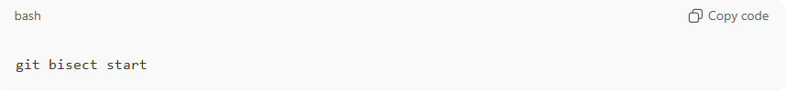
git bisect start
- Mark the bad commit (where the bug exists):
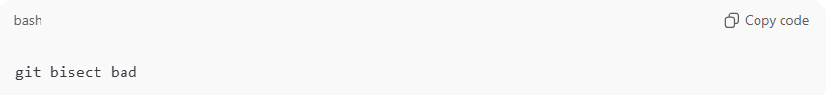
git bisect bad
- Mark the good commit (where the code worked):
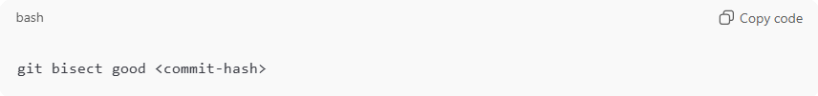
git bisect good <commit-hash>
- Git will checkout a commit in the middle of the range.
- Test the code:
  - If it’s bad, tell Git:
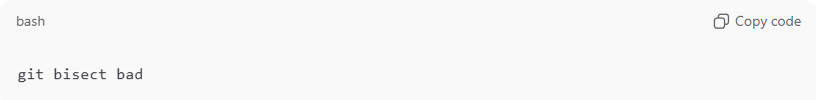
git bisect bad
  - If it’s good, tell Git:
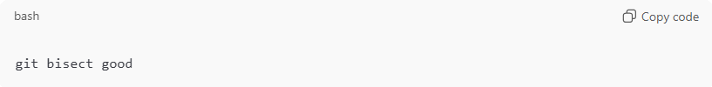
git bisect good
- Git will continue narrowing the search until it finds the first bad commit.

Example
# Source: AI Source: Provided by: [Data Path: Persons Table -> ID Column: 1, Name_En Column: Motasem Essam] -> From: [ChatGPT] on [2/15/2026]
Imagine you have 100 commits and suddenly a feature stopped working. Instead of checking all 100:
- Git bisect picks commit 50 → test → mark good/bad
- Git picks commit 25 → test → mark good/bad
- Repeat → find the bad commit in about 7 steps (log₂100 ≈ 7)

Advantages
# Source: AI Source: Provided by: [Data Path: Persons Table -> ID Column: 1, Name_En Column: Motasem Essam] -> From: [ChatGPT] on [2/15/2026]
- Saves time in large repositories.
- Can be automated with scripts for reproducible tests.
- Helps debug regression issues efficiently.

